High Ercall Primary School

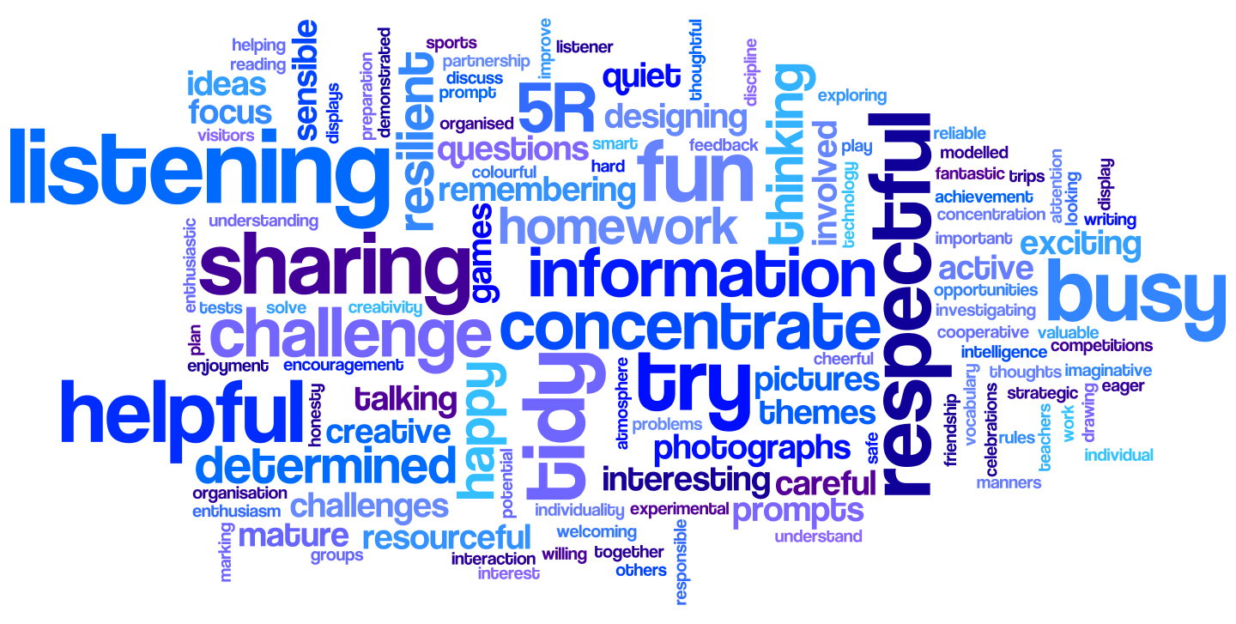

Religious Education Policy

Date of Policy Creation | November 2021 | Named Responsibility | Jemma Wallace
Date of review completion |  | Named  Responsibility | Jemma Wallace
Inception of new Policy |  | Named  Responsibility | Sarah Roberts
Date of Policy Adoption by Governing Body

Aims

At High Ercall Primary School we aim to support pupils so that they become independent and responsible members of society who understand and explore big questions about life, to find out what people believe and what difference this makes to how they live, so they can make sense of their own lives and those of others.

We follow the Telford and Wrekin Agreed Syllabus, SACRE (2021), for the teaching of RE. The syllabus aims:
• To stimulate interest and enjoyment in Religious Education.
• To prepare pupils to be informed, respectful members of society who celebrate diversity and strive to understand others.
• To encourage students to develop knowledge of the beliefs and practices of religions and worldviews, to develop informed opinions and an awareness of the implications of religion and worldviews for the individual, the community and the environment.
• To enable pupils to consider their own responses to questions about the meaning and purpose of life.

Knowledge forms the basis for progress in RE. The Telford and Wrekin Agreed Syllabus considers two types of knowledge: substantive (the what) and disciplinary (the how). In terms of substantive knowledge, the development of such is reflected through the curriculum units where a religion is revisited and different questions are asked/ knowledge provided as pupils move through school. With regards to disciplinary knowledge in RE we think about the methods (the ways children find out about religion) and the personal disciplinary knowledge, which relates to how the study of religion helps pupils to learn about themselves and their values.

Statutory Requirements

Our school curriculum for religious education meets the requirements of the 1988 Education Reform Act (ERA). The ERA stipulates that religious education is compulsory for all children, in maintained schools. The ERA allows parents to withdraw their child from religious education classes if they so wish, although this should only be done once the parents have given written notice to the governing body. The ERA also allows teachers and teaching assistants to refuse to teach religious education, but only after they have given due notice of their intention to the governing body in writing. The ERA states that the RE syllabus should reflect the fact that the religious traditions in Great Britain are in the main Christian, and that it should, at the same time, take account of the teachings and practices of other major religions.
The religious education curriculum forms an important part of our school’s spiritual, moral and social teaching and promotes education for citizenship. Our school RE curriculum is based on the Telford & Wrekin Religious Education agreed Syllabus 2021 (SACRE) and we use the Telford and Wrekin SACRE RE Scheme of Work to deliver our lessons.

Curriculum

We use the Telford and Wrekin SACRE Scheme of Work as the basis for our planning. The SACRE syllabus ensures breadth of study by requiring schools to focus on Christianity and one other religion at Key Stage 1 and Christianity and two other religions at Key Stage 2. This is a minimum requirement and other local religions will be mentioned and learnt about as children move through the school. Throughout the Agreed Syllabus there is an emphasis on conceptual development. The concepts taught must make sense to the child and be relevant to them. The syllabus states that ‘If pupils are able to make links with their own experiences they will be able to engage in deeper learning and see the relevance of what they are learning’. This will lead to children knowing more, understanding more and remembering more.
Due to our mixed year groups the organisation of our learning differs from the single year group Long Term Planning provided by SACRE but still builds a progressive curriculum with concepts that are revisited, and built upon, throughout the school career of each child. The concepts that we have chosen are; respect, belonging, worship, community, resurrection and festivals.

At High Ercall Primary School RE is taught for around an hour per week every other half term, alternating with PSHE, Relationship and Sex Education. Alongside classroom time we have regular visits from the local vicar, who performs an assembly once a month, and our Head teacher delivers further assemblies ensuring that we have a weekly assembly with an RE focus.
We have links with leaders from a local Sikh Gurdwara and an Islamic Mosque, who perform assemblies occasionally and offer visits for our children to experience their place of worship. As our school is situated opposite the local church we make visits throughout the year attending services as a school at Harvest and Christmas and visiting to learn more about Christianity at a time that links with the learning in each class. We know how relationships with members of local communities and local faith communities can enrich pupils’ experiences in RE and we strive to cultivate and maintain these relationships.

Our Long Term Planning follows a 2 year rolling programme (due to our mixed age classes) and is taught both discretely and with links to other subjects where possible. The concepts are revisited to develop knowledge and understanding and a list of useful vocabulary supports the teaching of each one.

Two year rolling programme:
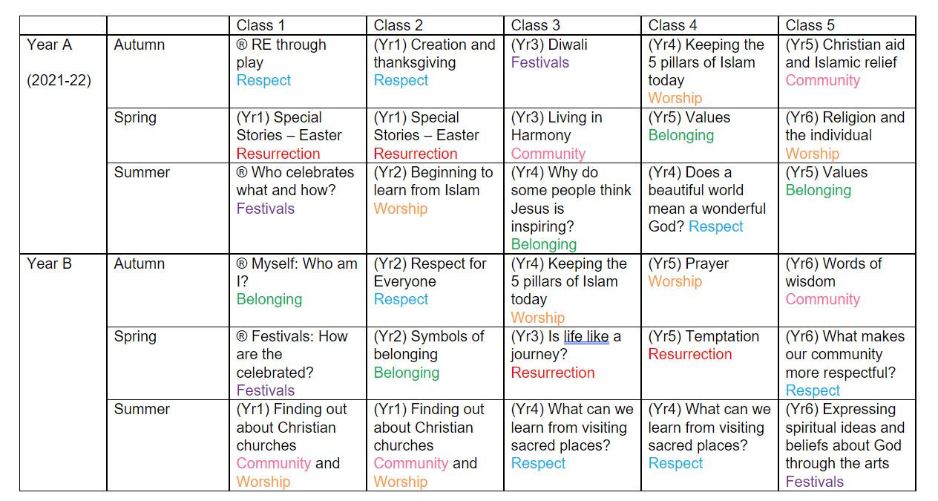

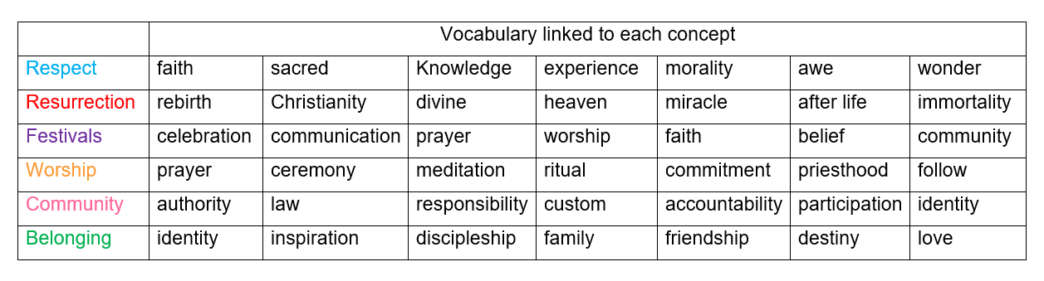

Teaching and learning

In accordance with Telford and Wrekin’s SACRE RE Scheme of Work we have agreed that:

Foundation Stage
We will teach religious education to all children in the school, including those in the Reception class. In Reception, religious education is an integral part of topic work covered during the year within Knowledge and Understanding of the World. We relate the Religious Education aspects of the children’s work to the objectives set out in the Early Learning Goals which underpin the curriculum planning for children in Reception. In Class 1 children will have opportunities to find out and learn about the world they live in. These experiences will include:
- learning about the beliefs and cultures of others;
- sharing the celebration of different festivals;
- hearing stories from a variety of cultural and religious traditions.

In the Early Years children:​
- should recognise similarities and differences between groups of people​
- should learn about what is special to different people​
- are introduced to specific words and concepts​
- begin to understand ritual​
- are encouraged to see and make links between different pieces of knowledge.

The curriculum for Key Stage 1 and 2 is broken down into three sections which contain differentiated objectives within those, found in the SACRE Scheme of Work. These are:
Section A – Know about and understand
Section B – Express and communicate
Section C – Gain and deploy skills

KS1 pupils will study Christianity as the principal focus and Islam as the major focus.

KS2 pupils will study Christianity as the principal focus, Islam as the major focus and Sikhism as a minor focus. Pupils will also learn about Hinduism and Judaism.

At High Ercall teaching staff create a safe environment where big questions can be asked and discussed without prejudice and children learn about, and respect, the beliefs of others. We aim to ensure the use of art, drama, thinking skills, speaking and listening activities, visits, posters, photographs, videos, ICT, artefacts, display work and other active learning strategies to support the delivery of our RE curriculum.

Inclusion

In our school we teach RE to all children. When teaching RE we ensure that we provide learning opportunities matched to the needs of children with learning difficulties or talents. We take into account the targets set for individual children in their Individual Education Plans (IEPs) and differentiate the tasks and outcomes as needed.

Assessment and recording

Learning in RE is monitored using the agreed syllabus and reviewed by looking at books and talking to children. Teachers also carryout formative assessment during their lessons through the use of observation, quizzes, mind maps for recall and drama or discussion. By making learning and assessment engaging children are more likely to recall the knowledge that they have been taught. In Key Stage 1 children may be asked to sequence pictures or build lego models for various stories that they have learnt about through RE as a way of assessment. In Key Stage 2 assessment may take the form of a research or debate session.
By delivering a fun, engaging, high-quality education, we provide children with the foundations for understanding the world around them and the means to communicate respectfully with others.

Monitoring and review

Planning, teaching and learning for RE is monitored by the RE Subject Leader and Head teacher as defined in the School Development Plan.

The RE subject leader is responsible for monitoring the standards of the children’s work. They are also responsible for supporting colleagues in the teaching of religious education, for being informed about current developments in the subject and for providing a strategic lead and direction for the subject in the school. The RE subject leader presents the Head teacher with an annual summary which evaluates the strengths and weaknesses in the subject and indicates areas for further improvement.

Policy Review: New policy created November 2021
To be reviewed in 2024 or before if the curriculum requires change.

